

**Name : varad patil**

**Roll no : 01**

**Subject: Prompt Engineering**

**SRN: 31241383**

First input :-

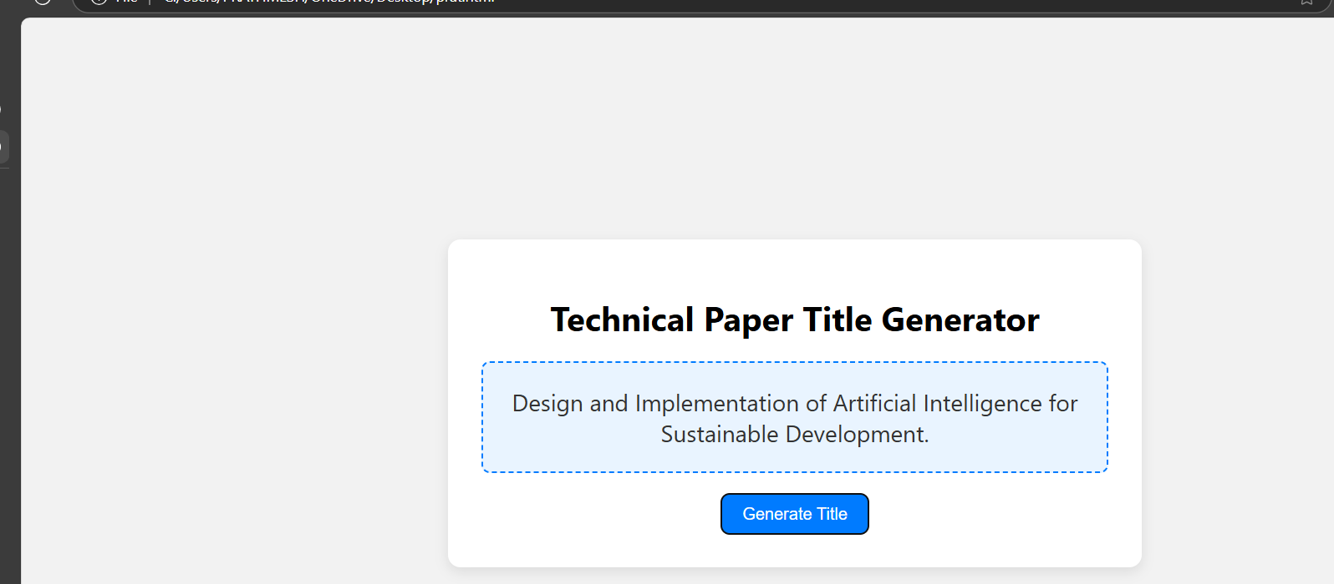

2nd input:-

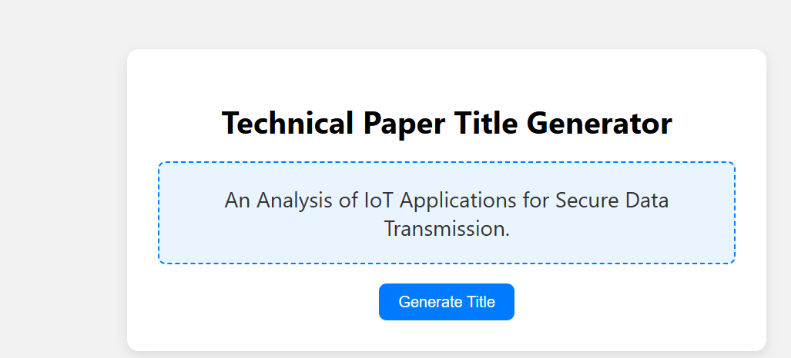

3rd input:-

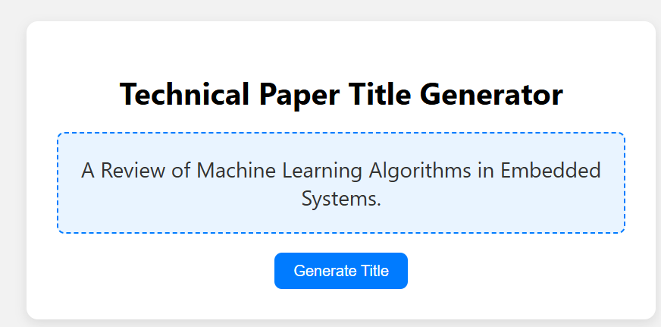

**CODE USED :-**

**<!DOCTYPE html>**

**<html lang="en">**

**<head>**

**<meta charset="UTF-8">**

**<title>Technical Paper Title Generator</title>**

**<style>**

**body {**

**font-family: 'Segoe UI', sans-serif;**

**background-color: #f2f2f2;**

**display: flex;**

**align-items: center;**

**justify-content: center;**

**height: 100vh;**

**margin: 0;**

**}**

**.container {**

**text-align: center;**

**background-color: white;**

**padding: 2em;**

**border-radius: 12px;**

**box-shadow: 0 4px 12px rgba(0, 0, 0, 0.1);**

**width: 90%;**

**max-width: 600px;**

**}**

**#title-box {**

**margin: 20px 0;**

**font-size: 1.4em;**

**color: #333;**

**padding: 1em;**

**border: 2px dashed #007BFF;**

**border-radius: 8px;**

**background-color: #e9f4ff;**

**}**

**button {**

**padding: 10px 20px;**

**font-size: 1em;**

**border: none;**

**background-color: #007BFF;**

**color: white;**

**border-radius: 8px;**

**cursor: pointer;**

**transition: background-color 0.3s;**

**}**

**button:hover {**

**background-color: #0056b3;**

**}**

**</style>**

**</head>**

**<body>**

**<div class="container">**

**<h1>Technical Paper Title Generator</h1>**

**<div id="title-box">Click the button to generate a title</div>**

**<button onclick="generateTitle()">Generate Title</button>**

**</div>**

**<script>**

**const beginnings = [**

**"A Study on",**

**"An Analysis of",**

**"Exploring",**

**"A Review of",**

**"Design and Implementation of",**

**"Optimizing"**

**];**

**const techTerms = [**

**"Machine Learning Algorithms",**

**"Blockchain Technology",**

**"IoT Applications",**

**"Cybersecurity Protocols",**

**"Cloud Computing Models",**

**"Quantum Computing",**

**"Edge Computing",**

**"Artificial Intelligence",**

**"Data Mining Techniques",**

**"Natural Language Processing"**

**];**

**const endings = [**

**"for Smart Cities",**

**"in Healthcare Systems",**

**"in Modern Education",**

**"for Sustainable Development",**

**"in Industry 4.0",**

**"with Real-Time Applications",**

**"for Secure Data Transmission",**

**"using Hybrid Models",**

**"with Enhanced Performance",**

**"in Embedded Systems"**

**];**

**function getRandomItem(arr) {**

**return arr[Math.floor(Math.random() * arr.length)];**

**}**

**function generateTitle() {**

**const title = `${getRandomItem(beginnings)} ${getRandomItem(techTerms)} ${getRandomItem(endings)}.`;**

**document.getElementById("title-box").textContent = title;**

**}**

**</script>**

**</body>**

**</html>**

**PROMPTS USED:-**

1} give me a code to make a tile name generater integrating api features.

2} make it dynamic where it can generate based on the custom additional details

3} optimize for server

Report by

Varad patil

Thank you ,